Display data :

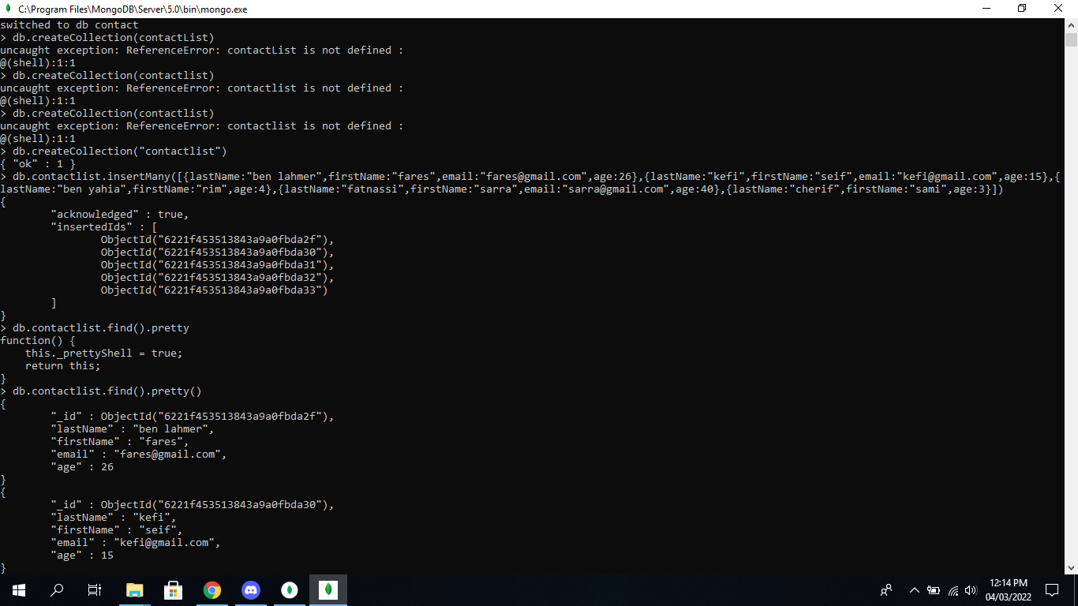



Display by ID :

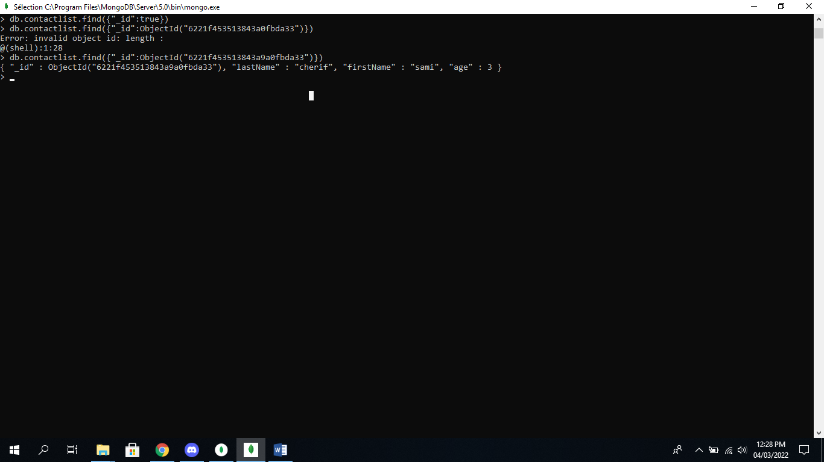

* Display all the contacts with an age >18.

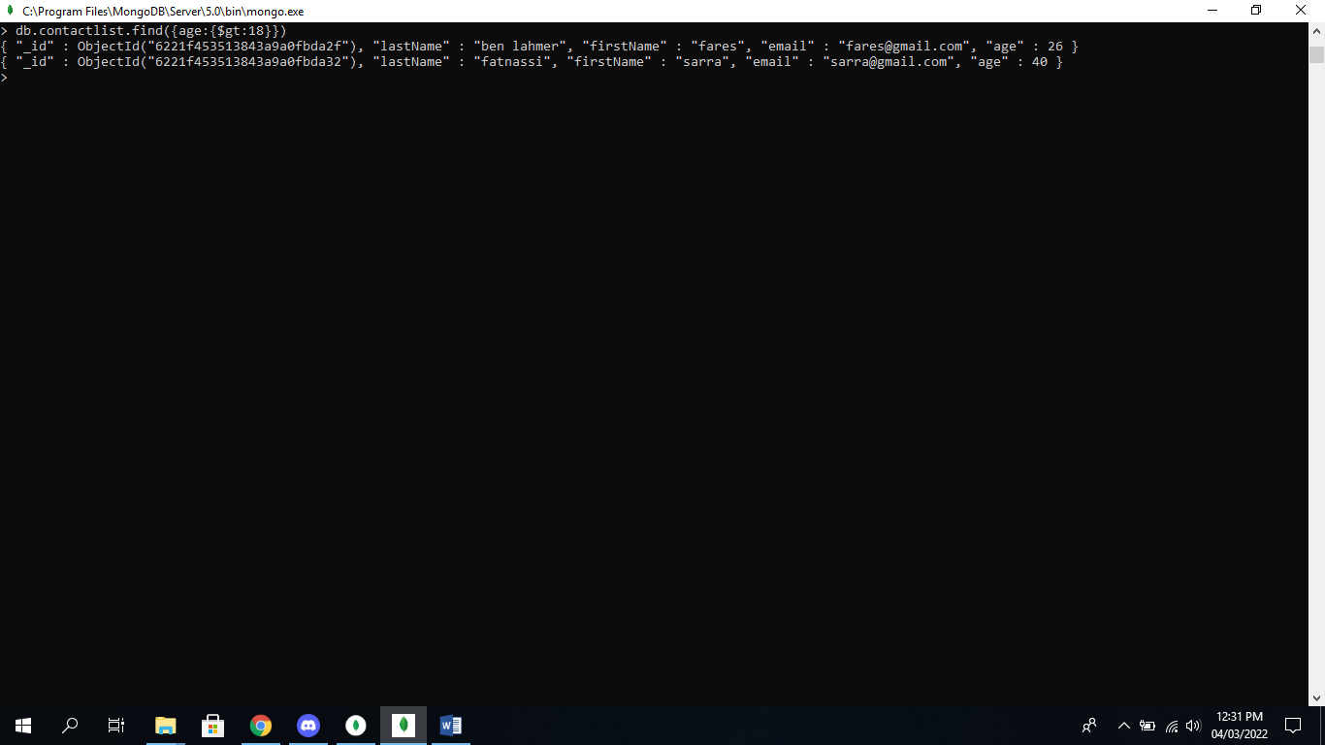

* Display all the contacts with an age>18 and name containing "ah".



* Change the contact's first name from"Kefi Seif" to "Kefi Anis".

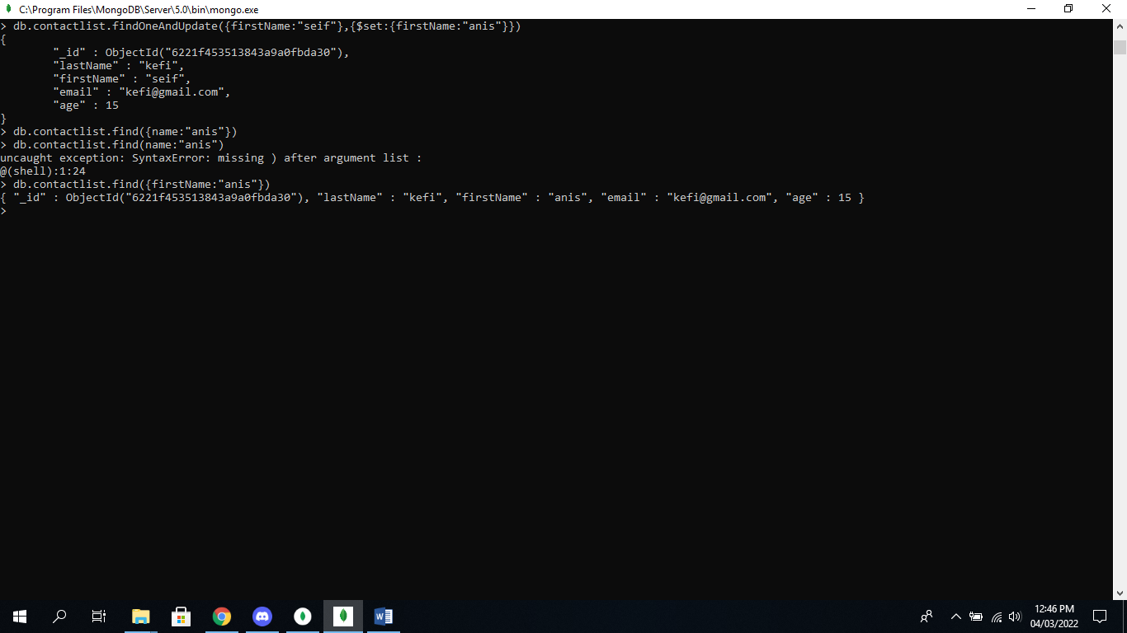

* Delete the contacts that are aged under <5
* Display all of the contacts list.

